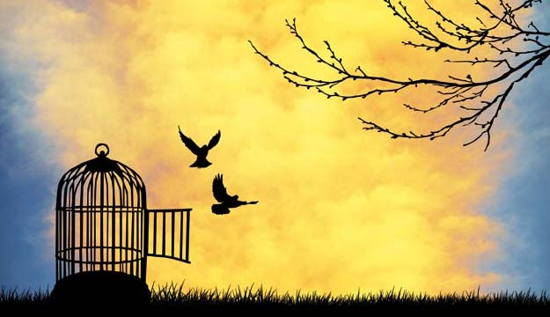

FREEDOM

Freedom consist not in doing what we like, but in having the right to do what we ought
Pope John Paul II
Freedom lies in being bold
Robert Frost
None are most hopelessly enslaved than those who falsely believe they are free
Johann Wolfgang von Goethe
It is difficult to free fools from the chains they revere
Voltaire
Those who deny freedom for others deserve it not for themselves; and under the rule of a just God, cannot long retain it
Abraham Lincoln
The only way to deal with an unfree world is to become so absolutely free that your very existence is an act of rebellion
Albert Camus
Free people, remember this maxim: we may acquire liberty, but it is never recovered if it is once lost
Jean-Jacques Rousseau
Is freedom anything else than the right to live as we wish? Nothing else
Epictetus
As long as men are free to ask what they must, free to say what they think, free to think what they will, freedom can never be lost and science can never regress
Marcel Proust
Freedom is absolutely necessary for the progress in science and the liberal arts
Baruch Spinoza
Freedom is a man’s natural power of doing what he pleases, so far as he is not prevented by force or law
Marcus Tullius Cicero
The secret of freedom lies in educating people, whereas the secret of tyranny is in keeping them ignorant
Maximilien Robespierre
Most people do not really want freedom, because freedom involves responsibility, and most people are frightened of responsibility
Sigmund Freud
This is the highest wisdom that I own; freedom and life are earned by those alone who conquer them each day anew
Johann Wolfgang von Goethe
I know but one freedom, and this is the freedom of the mind
Antoine de Saint-Exupery

